In resource constrained environment of embedded electronic, resource allocation is critical consideration. For tasks to be completed efficiently and within time frame, protocols are to be followed to allocate resources sufficiently. We know that, in hard real time systems, deadline miss can pose life threatening consequences. The operating system of any real time system follows these protocols to invoke its kernel to allocate resources on-demand for the executable processes. The seminar paper is a discussion on how the resource protocols are followed inside the OS.

Introduction:
A new process in real-time system starts with assigning different resources. These resources may vary from data structures, variables, memory (both volatile and non-volatile), files, registers, I/O to processors and others- depending on the task. As stated by Wang, “Starting a new process is a heavy job for the OS, which includes allocating memory, creating data structures, and coping code.” (Jiacun Wang 2017). Real-time embedded system utilizes sensors for data retrieval from its surrounding environment and to process those data, it depends on the controller or processors (Jiacun Wang 2017). “Real-time embedded systems are often run in highly resource-constrained environments, which make the system design and performance optimization quite challenging.” (Jiacun Wang 2017). Embedded systems with 8-bit processors are widely used in products like dishwashers, microwaves, coffee makers and digital watches. (Jiacun Wang 2017). “Most embedded systems are constrained in terms of processor speed, memory capacity, and user interface.” (Jiacun Wang 2017). “Therefore, embedded systems must be optimized in terms of size, weight, reliability, performance, cost, and power consumption to fit into the computing environment and perform their tasks. Thus, embedded systems typically require far more optimization than standard desktop applications.” (Jiacun Wang 2017).
“A resource access control protocol is a set of rules that govern when and under what conditions each request for resource is granted and how tasks requiring resources are scheduled.” (Jiacun Wang 2017). “A well-designed access control protocol can prevent deadlocks from occurring.” (Jiacun Wang 2017). Whereas, there is no protocol that can eliminate priority inversion, the goal of access control is to keep the blocking time of higher priority tasks under control. (Jiacun Wang 2017). “Any concurrent operating system (OS)must offer protocols to control the access to resources shared (i.e., a piece of code, such as data structures, I/O devices, buffers, and so on) by competing tasks, thus ensuring mutual exclusion in their respective critical sections (a code segment where shared variables can be accessed).” (dos Santos et al. 2023, p. 32).
“Typically, mutual exclusion is guaranteed by the use of binary semaphores, such as mutexes and suspension-based locks. Therefore, a task willing to enter a critical section must wait until another task, which holds the resource, exits the critical section. This is accomplished by calling the semaphore operations p (or wait) and v (or signal) before entering and after leaving each critical section, respectively. Real-time embedded applications also use semaphores to synchronize access to shared resources. However, specific resource access protocols are required to avoid unbounded priority inversions.” (dos Santos et al. 2023, p. 32). "Operating systems typically provide a general synchronization tool, called a semaphore, that can be used by tasks to build critical sections. A semaphore is a kernel data structure that, apart from initialization, can be accessed only through two kernel primitives, usually called wait and signal." (Buttazzo 2024, p. 187).
"When using this tool, each exclusive resource Rk must be protected by a different semaphore Sk, and each critical section operating on a resource Rk must begin with a wait (Sk) primitive and end with a signal(Sk) primitive. All tasks blocked on a resource are kept in a queue associated with the semaphore that protects the resource. When a running task executes a wait primitive on a locked semaphore, it enters a waiting state, until another task executes a signal primitive that unlocks the semaphore. When a task leaves the waiting state, it does not go in the running state, but in the ready state, so that the CPU can be assigned to the highest-priority task by the scheduling algorithm." (Buttazzo 2024, pp. 187–188).
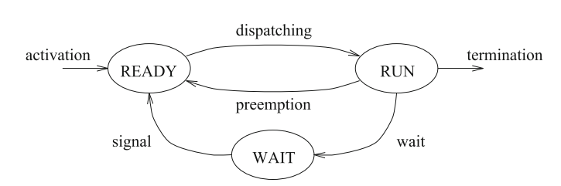
Figure 1: Waiting state caused by resource constraints (Buttazzo 2024, p. 188)
"When a process is started, the OS allocates memory to the process and then loads the load module from disk into the memory allocated to the process. During the loading, the executable code and initialized data are copied into the process’ memory from the load module. In addition, memory is also allocated for uninitialized data and runtime stack that is used to keep information about each procedure call. The loader has a default initial size for the stack. When the stack is filled up at runtime, extra space will be allocated to it, as long as the predefined maximum size is not exceeded." (Jiacun Wang 2017). Resources, in case of real-time systems, are commonly referred to as data structures, variables, main memory area, files, registers, and I/O units, as is mentioned in(Jiacun Wang 2017, p. 99).
We can assume m type of resources in a system, namely R₁, R₂, R₃………, R_{m} where each resource comprises η_{i} number of indistinguishable units of R_{i}, i=1, 2, …., m. When a task requests ρ_{i} units of a resource R_{i,} request is sent to kernel to lock them and can be denoted as L(R_{i,} ρ_{i}). When the resource is longer needed by the task, it is unlocked and can be denoted by U(R_{i,} ρ_{i}). As plentiful resources have no effect on scheduling plentiful resources have no effect on scheduling (University of Glasgow), we can avoid considering them here. Also to be considered here- only the serially reusable resources, which are "one that can be used safely by one task at a time and is not depleted by that use" (Jiacun Wang 2017, p. 99). The examples of these resources are devices, files, databases, and semaphores (Jiacun Wang 2017, p. 99). The access to resources by every task will be controlled by locking mechanisms.
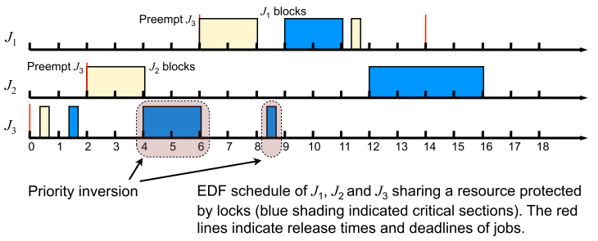
Figure 2: EDF scheduling of tasks, while resources are protectd by locks. (University of Glasgow, p. 4)

Publication bibliography
Buttazzo, Giorgio (2024): Hard Real-Time Computing Systems. Predictable Scheduling Algorithms and Applications. 4th ed.: Springer Nature.
dos Santos, Lucas Matheus; Gracioli, Giovani; Kloda, Tomasz; Caccamo, Marco (2023): Supporting single and multi-core resource access protocols on object-oriented RTOSes 27, pp. 31–50. DOI: 10.1007/s10617-023-09268-6.
Jiacun Wang (2017): Real-Time Embedded Systems. 111 River Street, Hoboken, NJ 07030, USA: John Wiley & Sons, Inc. (Quantitative Software Engineering Series).
University of Glasgow: Resource Access Control in Real-time Systems. Advanced Operating Systems (M). Available online at https://csperkins.org/teaching/2011-2012/adv-os/lecture08.pdf, checked on 5/11/2025.

